**Deploying GKE Cluster with gcloud utility**

[Google Container Engine](https://cloud.google.com/container-engine/) (GKE) is a service by Google for running containerized applications. It provides the simplest and most common way of setting up a Kubernetes Cluster in minutes

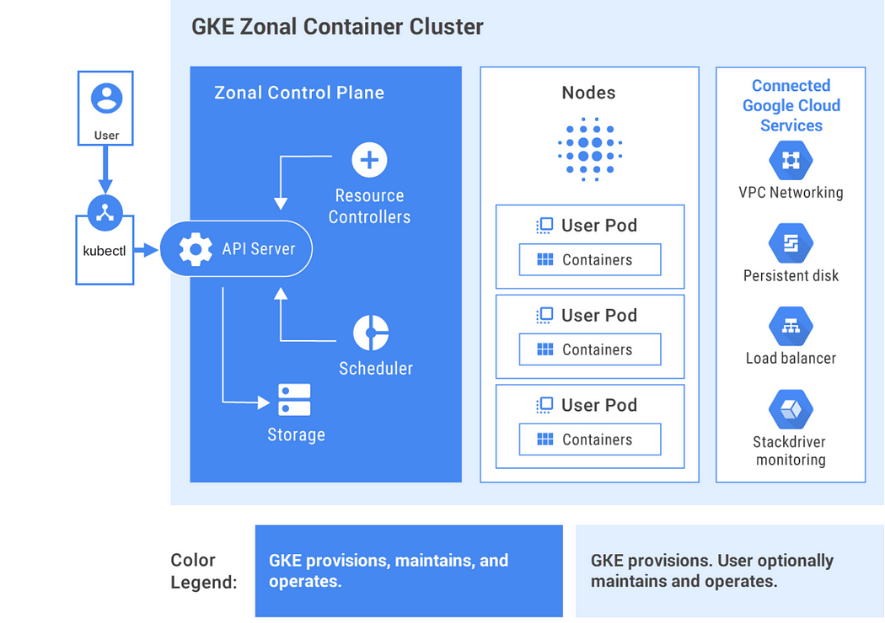

1. Create initial configuration in gcloud and list it for verification.

$ gcloud init --console-only # to setup default configuration

$ gcloud config configurations create <Cluster_Name> # creating custom config

$ gcloud config configurations list

$ gcloud info

1. Install gcloud component as per the requirement.

$ gcloud components list # Listing gcloud components

$ gcloud components install kubectl # if kubectl not available

$ gcloud components update # if required

1. Create GKE Cluster Setup

$ gcloud container clusters create **<cluster_name>** --machine-type n1-standard-2 --num-nodes **2** --zone **us-central1-c**

# Verify K8s GKE Cluster details

$ gcloud container clusters list

$ gcloud container clusters get-credentials <cluster_name> --zone us-central1-c --project <project_name>

1. Verify K8s Cluster nodes created by GKE service

$ kubectl get nodes -o wide

$ kubectl config view

$ kubectl config current-context

1. Verify K8s Cluster nodes

$ kubectl create deployment <deployment_name> --image=<image-id>

# Pod Status

$ kubectl get pods -o wide

$ kubectl expose deployment <deployment_name> --type LoadBalancer --port 80 --target-port 80

$ kubectl get services

1. To update the cluster for the number of nodes or zone

$ gcloud container clusters resize <clust_name> --num-nodes 3

$ gcloud container clusters update <cluster-name> --zone us-central1-a

$ gcloud container clusters delete <cluster-name> --zone us-central1-c  
  
$ gcloud config configurations delete <cluster-name>

$ gcloud projects delete <project-name>